Temporal Holdout Verification
As a more interesting point, a big question faced is whether this modeling technique would have predicted the subprime bubble of 2007. Temporal holdout was performed to backtest the model accuracy and investigate the answer to this question. The software was recoded to use the end of second quarter 2006 as the end horizon. The only change in our models was that the coefficients were re-estimated to reflect the truncated data set. Curve fitting of the predictors was performed using only data from the middle of 2006 with the same methodology as done for the middle of 2008.

The national home sales and prices both fell dramatically in March 2007; the steepest plunge since the 1989 Savings and Loan crisis. This is why backtesting the forecasting ability from the middle of 2006 is important: to determine if the bubble burst may have been predicted several quarters in advance.

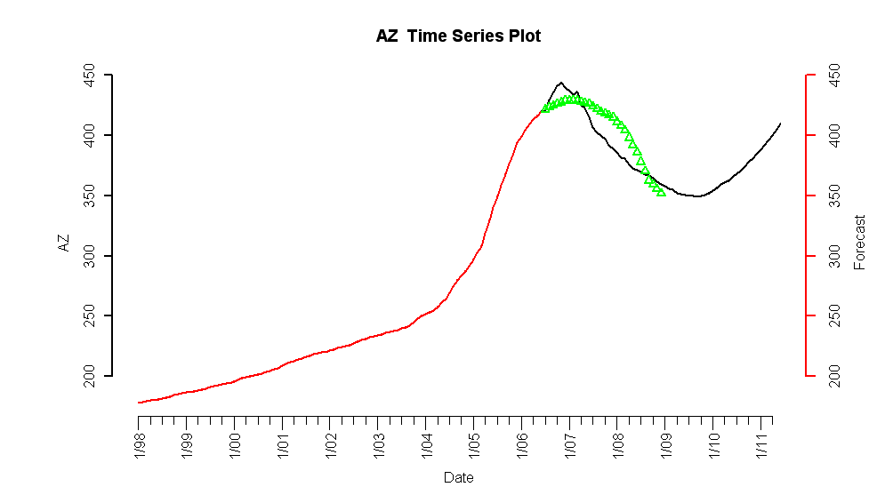
Figure 1.1.1: Temporal Holdout Verification for Arizona

Arizona is one of the states that face a large housing bubble with currently the third highest foreclosure rate in the nation. The temporal hold verification in Figure 1.1.1 indicates the model predicted a peak in the Arizona HPI in third quarter of 2006 while the actual peak occurred in first quarter of 2007. With the benefit of observed data through 2008, the model predicted relatively well the magnitude and slope of decline. The bottoming out of the HPI in mid 2009 may actually be a reality with the steps the Obama administration has taken, as well as the recent recovery of the equity markets.
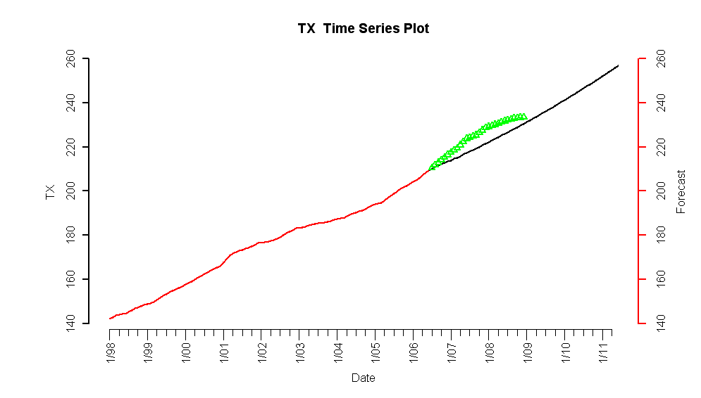

Figure 1.1.2: Temporal Holdout Verification for Texas
Texas was an interesting candidate for temporal holdout verification as their HPI was one of the few that were not subject to the repercussions of the subprime crisis. As shown in Figure 1.1.2, forecasts indicate a relatively steady increasing HPI. The forecast was actually on the conservative side; understating the returns of the true HPI. However, the values appear to be converging as 2009 progresses.

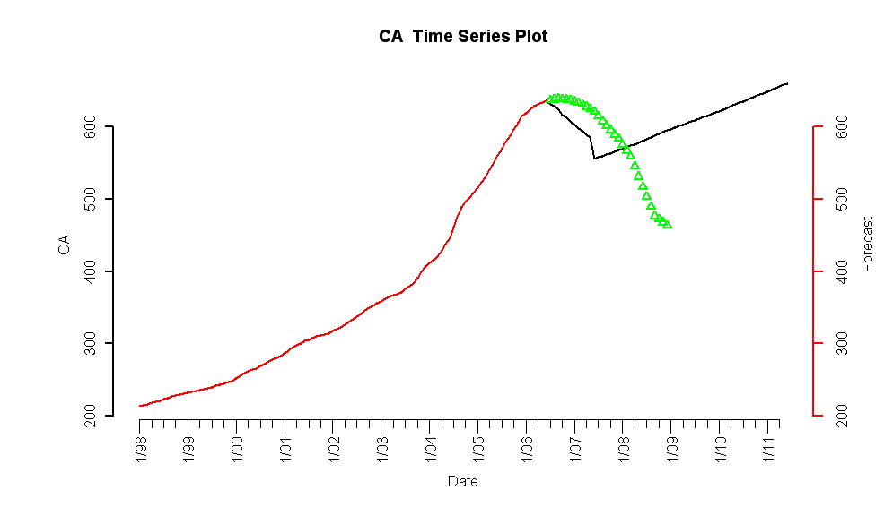
Figure 1.1.3: Temporal Holdout Verification for California
California has state economics similar to Arizona, and is facing an even higher foreclosure rate. As a state subject to a large speculative bubble, temporal holdout verification had an interesting result. Shown in Figure 1.1.3, the forecasts predicted an immediate drop in the HPI from the forecast horizon with a turnaround in the middle of 2007. The timing of events did deviate substantially from their actual occurrences, but direction of change was initially predicted. However, as more observable data became available the coefficient estimates could be re-estimated to provide better forecasts.
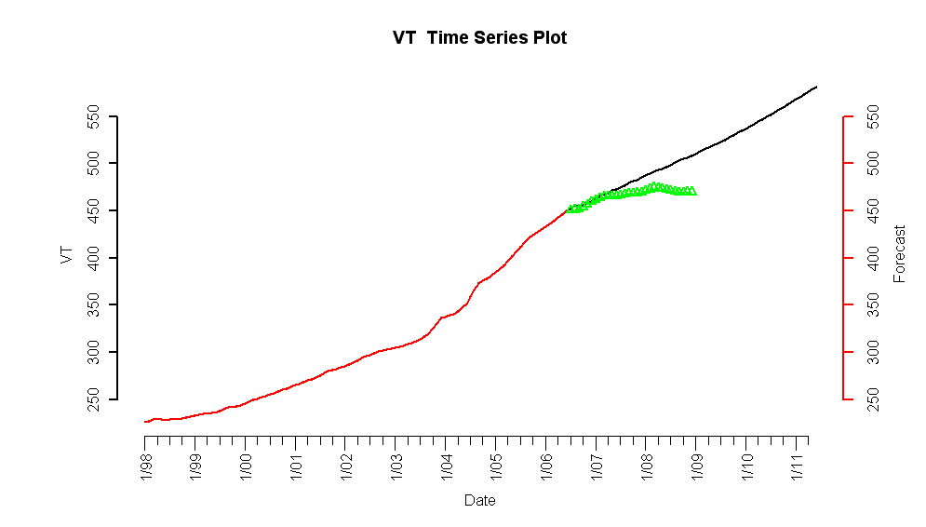
Figure 1.1.4: Temporal Holdout Forecast for Vermont

Vermont was an interesting case study where the HPI leveled off in the last couple years. As shown in Figure 1.1.4, forecasts following the observed value through the first quarter of 2007. However, at this point the HPI has remained steady while the forecasts indicated an increasing trend. The noteworthy fact remains that the three quarters of forecasting bared remarkable prediction power. A near term rebound could cause the observed values to converge; however, large gains are unlikely.

Additional Temporal Holdout Validation
Temporal holdout validation was performed on other states – the results are similar to one of the scenarios previously presented.
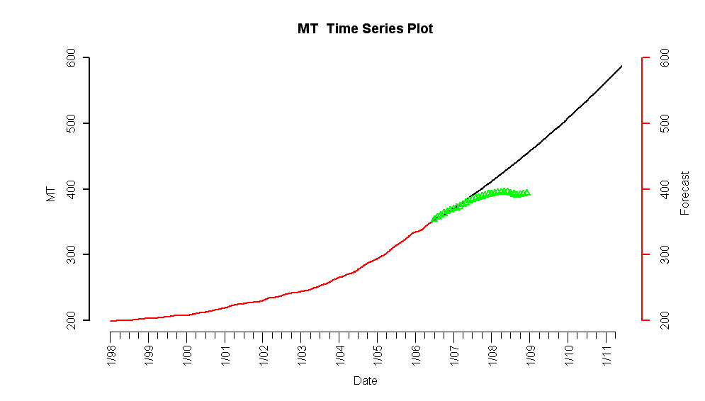
Figure 1.1.5: Temporal Holdout Forecast for Montana

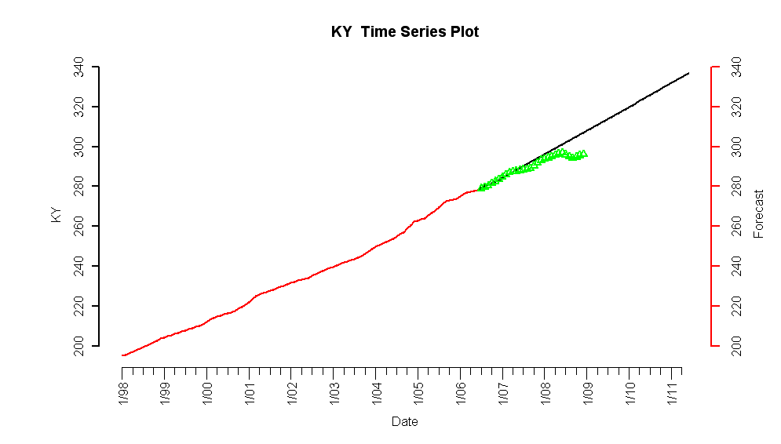
Figure 1.1.6: Temporal Holdout Forecast for Kentucky

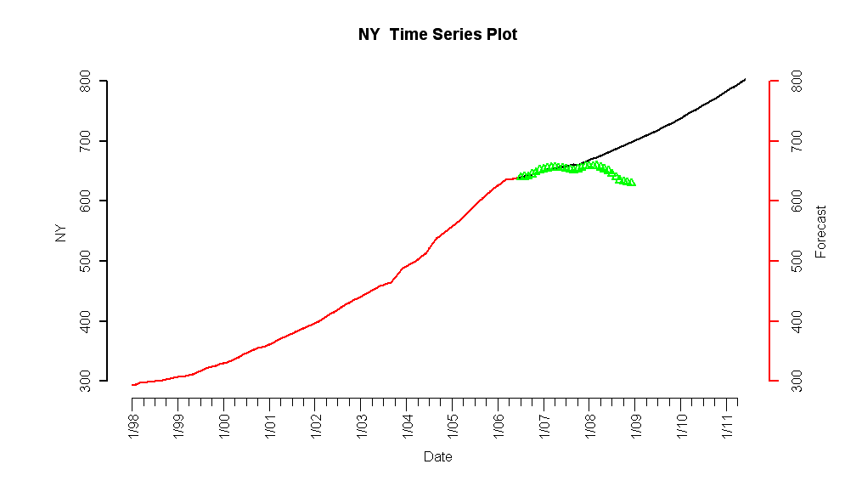
Figure 1.1.7: Temporal Holdout Forecast for New York

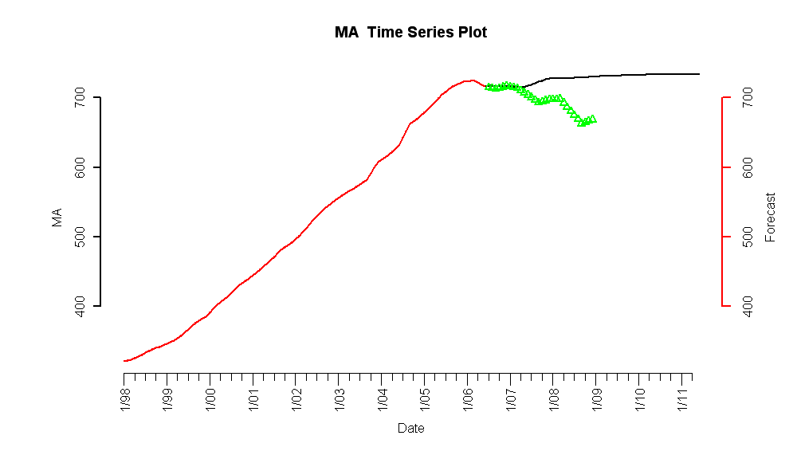
Figure 1.1.8: Temporal Holdout Forecast for Massachusetts

